***Buy vs. Rent***

Reid Zuerlein, Jacob Baron, Lucas Lantis, Ben Hoffman

In making the decision to buy or rent a home, there are many factors that must be taken into consideration. Through both quantitative and qualitative analysis, we conclude that by purchasing her condo instead of renting, Rebecca can maximize her savings over the long-term regardless of market outlook.

To begin, we determined Rebecca’s monthly mortgage payment based on a purchase price of $480,000 (after putting 20% down) with an effective monthly rate of .33059%. This gave us a monthly mortgage payment of $2,516.58 (figure 1). However, in order for Rebecca to make the down payment of $120,000, as well as pay for the closing fees and other taxes, she will have to withdraw that money which is currently being invested and earning the same effective monthly rate of .33059%. Therefore, the opportunity cost of withdrawing this money to purchase a condominium is $462.82 (figure 2).

As a renter, Rebecca is currently paying $3,000 a month. As an owner, Rebecca will not only have to pay her mortgage payment of $2,516.58, but also monthly condos fees of $1,055, monthly property taxes of $300, and monthly repairs of $50. This gives Rebecca a total monthly cost of $3,921.58 (figure 1). However, since Rebecca must also withdraw $140,000 of her investments to cover the down payment and closing costs, her monthly cost is $4,384.40 when including the opportunity cost of $462.82. Therefore, it costs Rebecca $1,384.40 more every month to own her condo, rather than rent it (figure 3). While that may seem high, we must look long-term to evaluate the true costs of ownership considering that she will be able to sell the condo.

To determine Rebecca’s gain or loss if she decides to sell the condo at different points in time, we calculated the remaining principal on the mortgage after 2, 5, and 10 years (figure 4). We calculated that, at these points in time, the principal remaining on Rebecca’s 25-year mortgage is $455,104.77, $416,481.95, and $340,981.76 respectively. From here, we analyzed Rebecca’s costs and return dependent on different condo market outlooks:

A.) The condo price remains unchanged

B.) The condo price drops 10% over the next two years, then increases back to its purchase price by the end of five years, then increases by a total of 10% from the original purchase price by the end of 10 years

C.) The condo price increases annually by the annual rate of inflation of 2% per year over the next 10 years

D.) The condo price increases annually by an annual rate of 5% per year over the next 10 years

All of these scenarios were analyzed depending on if Rebecca chose to sell 2, 5, or 10 years into her mortgage. Rebecca’s gain in these situations was calculated by taking the condo’s sales price and subtracting realtor fees, closing fees, the future value of payments and the outstanding mortgage principal. We recommend that Rebecca purchases the condo rather than renting because, in all of the analyzed scenarios, she will realize a gain above what she would have if she rented.

The best case scenario for Rebecca would be to sell the condo after 10 years assuming that prices rise 5% annually over 10 years. In this situation, she would see a gain of $381,988.81. The worst outcome would be to sell after two years after condo prices have fallen 10% annually. She would only see a gain of $21,261.14, the lowest of any predicted outcome. All of the different analyzed scenarios and their respective outcomes are visible in Figure 5.

Beyond the quantitative analysis, Rebecca must also take some qualitative considerations into account. If Rebecca is planning to grow her family, a condo might not be suitable to buy or rent as more space will be needed for a young family. She might want to look at a house instead or just rent for the short-term as her family situation becomes more concrete. Rebecca must also consider the pride of owning a home versus just renting a place to live. She will also not be “throwing away her money,” because she will at least get some money when she chooses to sell. Finally, as an investment banker, Rebecca’s job is extremely volatile. She could easily be transferred to a new city, sign a new contract, or be let go from her current position. Rebecca needs to consider her job stability.

***Appendix***

**Figure 1**

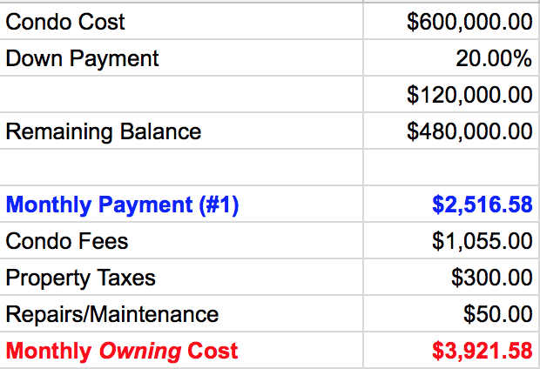

**Figure 2**

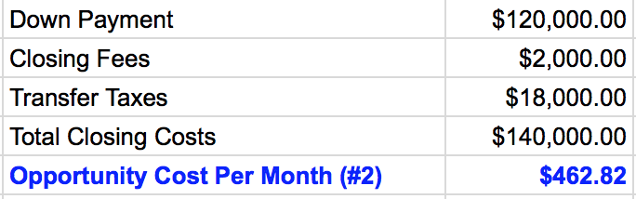

**Figure 3**

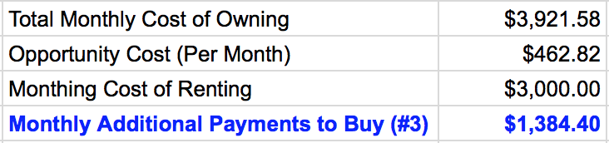

**Figure 4**

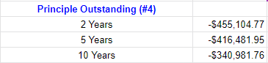

**Figure 5**